

Practices for Secure Software Report

Table of Contents
Practices for Secure Software Report 1
Document Revision History 3
Client 3
Instructions 3
Developer 4
1.Algorithm Cipher 4
2.Certificate Generation 4
3.Deploy Cipher 4
4.Secure Communications 4
5.Secondary Testing 4
6.Functional Testing 4
7.Summary 4
8.Industry Standard Best Practices 4

Document Revision History

Version | Date | Author | Comments
1.0 | 12/08/23 | Christian Tavares | Initial Draft

Client



Instructions

Submit this completed practices for secure software report. Replace the bracketed text with the relevant information. You must document your process for writing secure communications and refactoring code that complies with software security testing protocols.

- Respond to the steps outlined below and include your findings.
- Respond using your own words. You may also choose to include images or supporting materials. If you include them, make certain to insert them in all the relevant locations in the document.
- Refer to the Project Two Guidelines and Rubric for more detailed instructions about each section of the template.

Developer
Christian Tavares

Algorithm Cipher

The algorithm cipher I would recommend for this project would be AES. My reasoning is because it fits the java encryption standards for reaching a minimum size of 128 bits and it allows for asymmetric and symmetric encryption. The reason why bit levels matter is because simply making the bit level higher means that it is more difficult to brute force the encryption. You can think of it like adding numbers to a combination lock. The more you have, the more possible values exist. It adds a little extra security.

For something of this scale, symmetric encryption may actually be the better option since there is expected to be a lot of information getting passed through. This means that with asymmetric encryption, this means that encryption and decryption would have a different key. While this definitely adds more security to the program, it is simultaneously going to increase your workload by quite a bit.

In terms of the history of our encryption algorithm, it has a very reputable history in being a secure standard. Sure, AES may be a bit dated when thinking about the field of technology but it still certainly holds up just fine today. Our vulnerability checks will help to mitigate that possibility if it should arise.

Certificate Generation
Insert a screenshot below of the CER file.

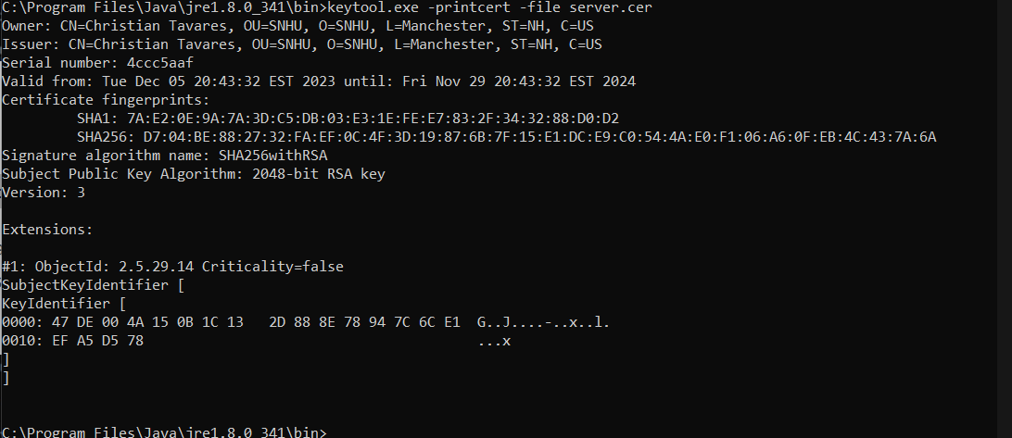

Deploy Cipher
Insert a screenshot below of the checksum verification.

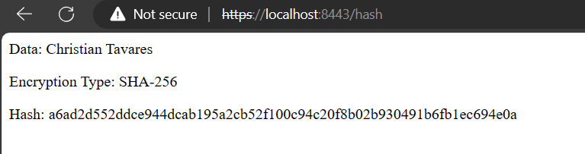

Secure Communications
Insert a screenshot below of the web browser that shows a secure webpage.

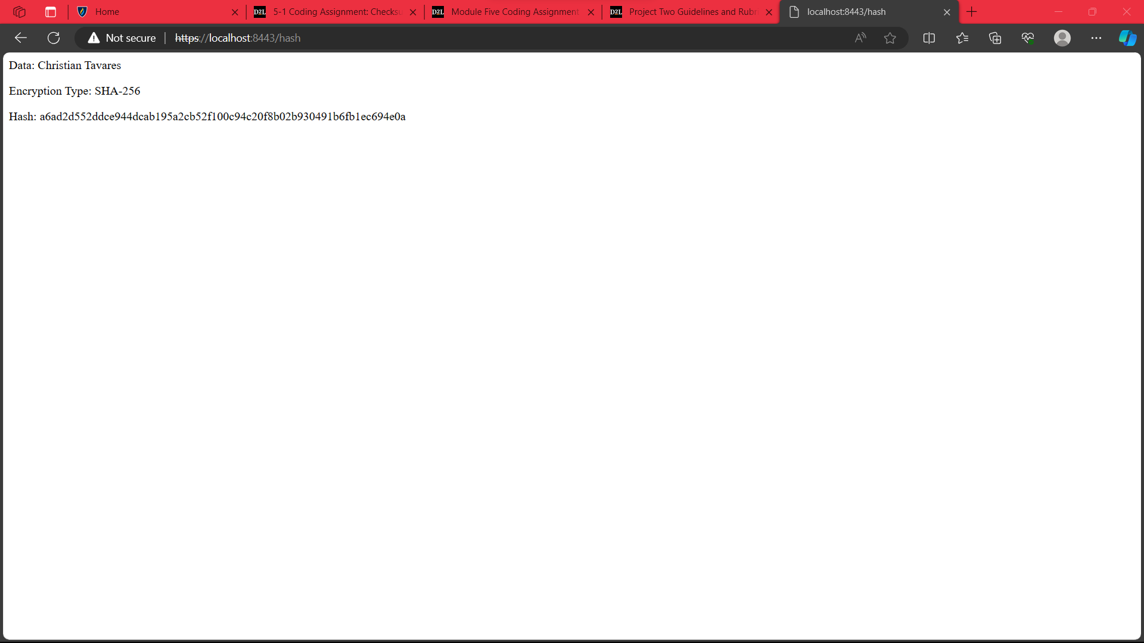

Secondary Testing
Insert screenshots below of the refactored code executed without errors and the dependency-check report.

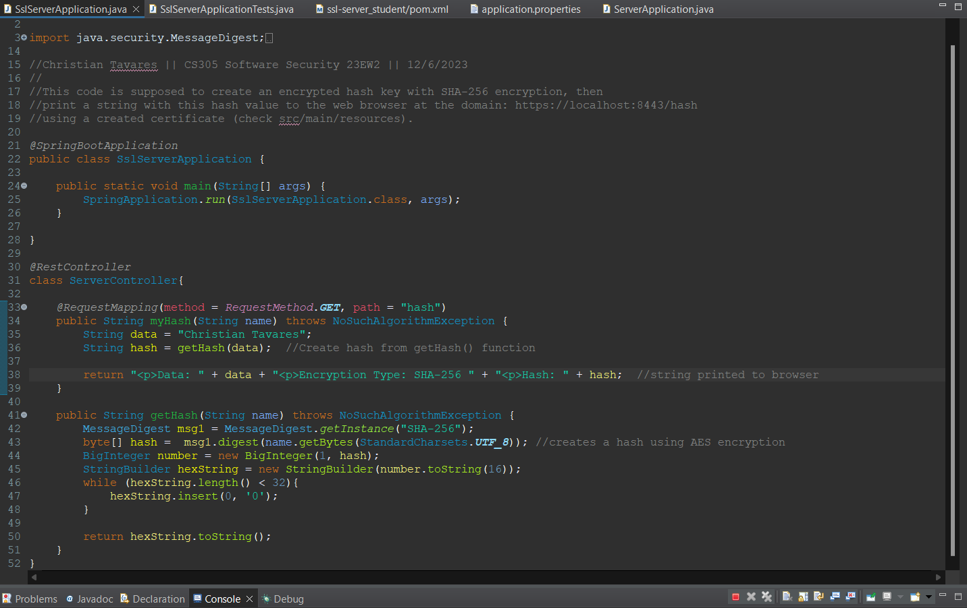

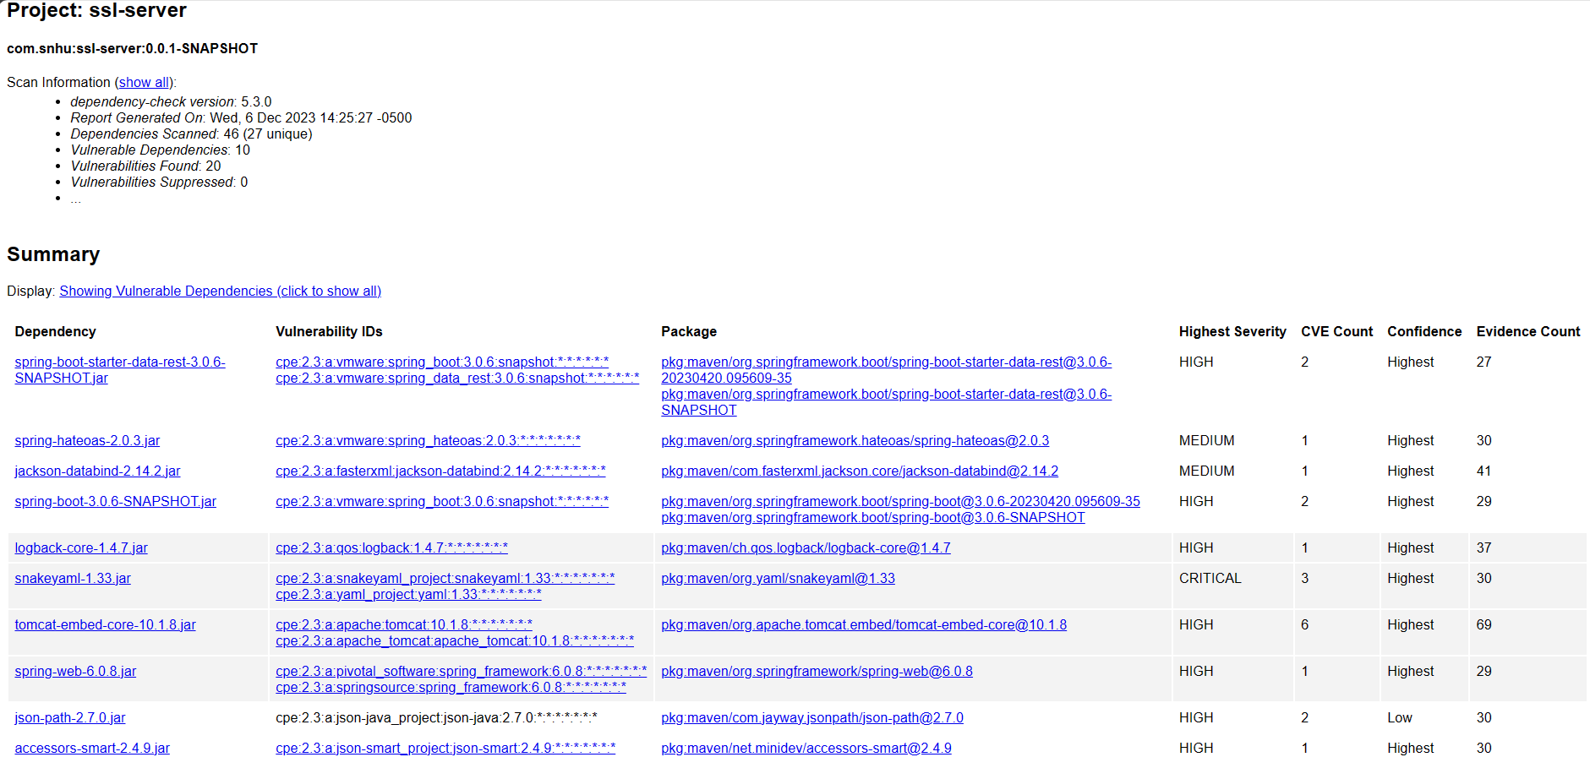

Functional Testing
Insert a screenshot below of the refactored code executed without errors.

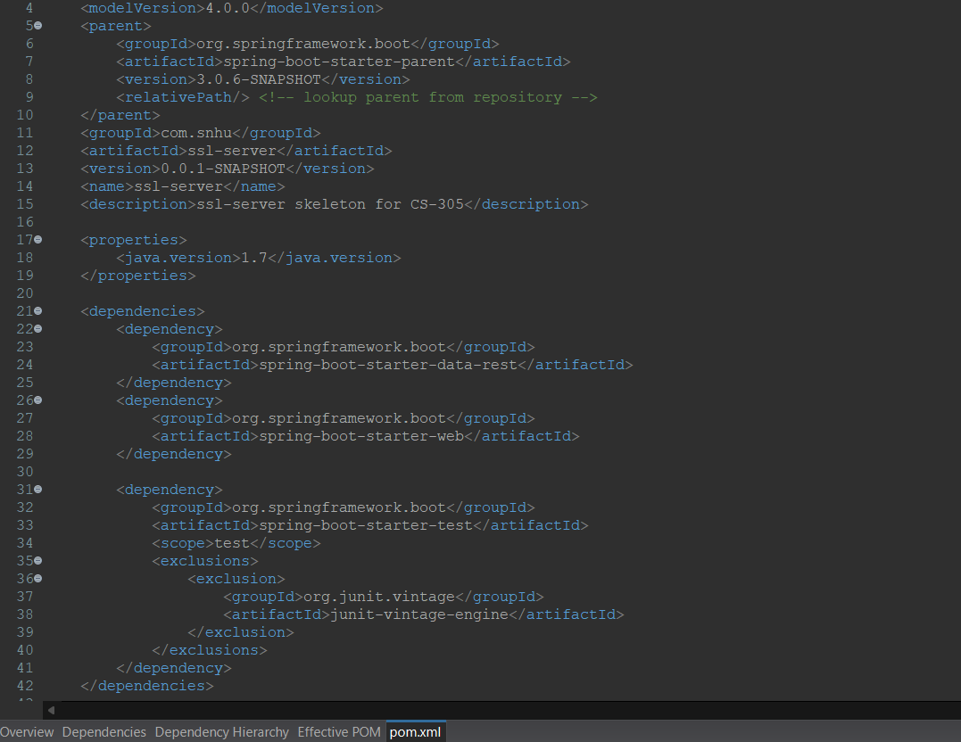

Summary

If we look at the Vulnerability Assessment Flowchart, I would argue that our refactored code could fall under all categories aside from maybe Encapsulation and Code Quality. My reasoning is because I'm sure my quality could be improved with a finer understanding of software security, and my Encapsulation could probably use some work as well, but the program is pretty simply in terms of the amount of functions running within it.
Aside from this, Input Validation works because that is sort of the whole point of the refactoring. We are trying to verify a certificate to open a webpage, which requires proper Input Validation to verify. APIs factors into our refactoring because of the edits to our pom.xml file in order to ensure secure interactions with the spring API. Cryptography is obvious, but this is due to the fact that we are generating and encrypting a hash key with this program. Client/Server because we are hosting a page to display the hash information, then finally Code Error because this is standard practice for all coding. You want to have solid error handling.

The process involved for adding layers of security began with the cipher algorithm. We knew we needed this, so we decided on an algorithm based on java software standards like the hash bit size and asymmetric versus symmetric hashing. Both of which add another layer. After that we incorporated a certificate to be used to verify the webpage being hosted. This certificate then was established through the HTTPS protocol with information we loaded in regarding the certificate used. These are both 2 more layers of security.
While it's not the absolute MOST secure it can be, there are certainly layers involved here. We can even go steps further and create a role based system as well.

Industry Standard Best Practices

I applied industry best standards to this project starting with the Vulnerability Assessment Flowchart. It allows a good highlight of what is needed for the assignment and where to focus with the code refactoring. Industry standards were also applied with the choice of an algorithm. I went down the steps one should employ when using an algorithm cipher for a java program by remembering the hash key bit length, as well as some algorithms to avoid. I would also say that using the maven dependency-check plugin is also applying industry standards through monitoring our code for various vulnerability CVE codes that could apply to our software. There are of course false positives to keep in mind, as this is not a system without it's flaws, but it certainly has usage.
Maintaining these industry standards is important because it is an extremely solid backbone to keep your code fairly secure. As mentioned previously, this is never a perfect strategy, but it will give you a great guideline to follow and tweak as needed for the project. The important thing is consistency and maintenance. The digital world is constantly changing, so keeping tabs and monitoring things (as well as making adjustments as able) will go a long way to keeping you secure.

